**Name:** Rosalynn Alejandro

**Date Created:** June 29, 2025

**Program Description:**

Writing program (RosalynnAlejandro_ProgrammingExercise_CSV): This program will help a teaching instructor save a desired number of students, and their respective number grades for three exams in a grades.csv file.

Reading program (RosalynnAlejandro_ProgrammingExercise_CSVreader), will read and display the contents of the grades.csv file

**Functions used in the Program (list in order as they are called):**

1. **Function Name:** main()

**Description:** This function will get input from the instructor for the students first and last names, and three exam grades for their desired amount of students.

**Parameters:** None

**Variables:**

1. students, the number of students input from the instructor
2. first_name, the students first name
3. last_name, the students last name
4. exam1, calls grade_validate() to get numeric grade for first exam
5. exam2, calls grade_validate() to get numeric grade for second exam
6. exam3, calls grade_validate() to get numeric grade for third exam

**Logical Steps:**

1. Get the number of students
2. Open grades.csv for writing
   1. For the number of students, get each students first and last name, and their three exam scores
   2. Write each students information in a new row in the grades.csv file
3. Display the input has been saved to the grades.csv file

**Returns:** none

2. **Function Name:** grade_validate()

**Description:** This function will get the numeric grade for three exams for each student and ensure valid integer inputs

**Parameters:** 1, 2, and 3. This function will run three times for the three exams.

**Variables:**

1. grade, this is the numeric grade for each time the grade_validate() function runs, then assigns it to exam1, exam2, and exam3 respectively

**Logical Steps:**

1. get the numeric grade for an exam
   1. ensure the grade is a valid integer

**Returns:** grade, the numeric grade for exam1, exam2, and exam3

**Logical Steps:**

1. Import csv module
2. In main()
   1. Get the amount of students from the instructor
   2. Open the grades.csv file for writing
   3. For the amount of desired students, get the first and last names, and numeric exam grades for three exams
   4. Display that the data was written to grades.csv
   5. Display instructions for the viewing grades.csv content
3. In grade_validate() (this function will run three times)
   1. Get the grade input from instructor
   2. Validate the numeric grade between 0-100
   3. Return grade

**Link to your repository:** <https://github.com/ficklative/COP2373/tree/master>

**Output Screenshot:**

Screenshots are on the next two pages.

**Writer:**

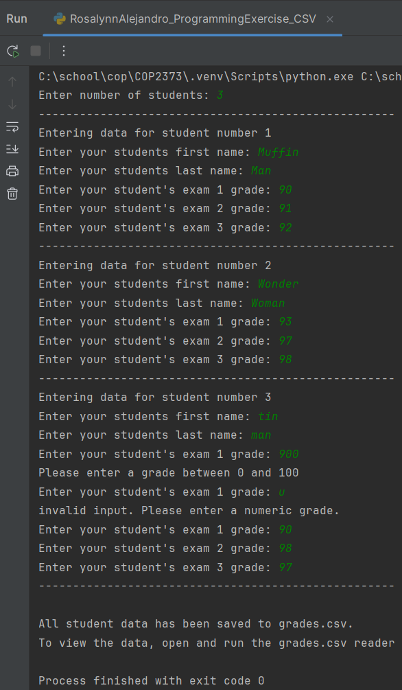

**Reader:**

